III-I ARTIFICIAL INTELLIGENCE MID-I QUESTION BANK (UNIT-I,II,III)
UNIT-I: Short Answer Questions
1.Define an Intelligent Agent and state its primary components.
2. Discuss bidirectional search with example.
3.Distinguish between Informed Search and Uninformed Search strategies.
4. Differentiate Depth-limited search and iterative deepening depth-first search.
5.Why is Iterative Deepening Depth-First Search (IDDFS) preferred over standard Depth-First Search?
6.What is a Heuristic Function? Give an example
7.Define Greedy Best-First Search.
8.Briefly discuss the concept of searching with non-deterministic actions.
9.What is an Online Search Agent?
10.Define Partially observable Environment?
UNIT-I: Essay Questions
1. Explain any 3 intelligent agents with neat diagram.
2. What are the limitations of Hill Climbing Search, and how can they be overcome? Solve the following blocks world problem.
A D
D C
C B
B A
Initial State Goal state.
3. Explain the AND-OR search trees with respective to non-deterministic environment.
4. Explain Hill climbing search with an example. What are the issues in Hill climbing search? How are they solved?
5. Illustrate Uniform cost search algorithm with an example
 | 6 | Discuss Greedy Best First Search algorithm for 8 puzzle problem.  Initial state  Goal State
  2 | 8 | 3
  1 | 6 | 4
  7 |  | 5
  1 | 2 | 3
  8 |  | 4
  7 | 6 | 5

7. Apply A* algorithm on the following problem. Where A=initial state and I =Goal State
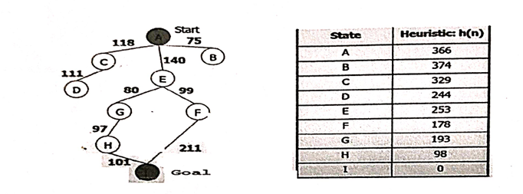
8. Apply Breadth First search and Depth First search for the following Graph.
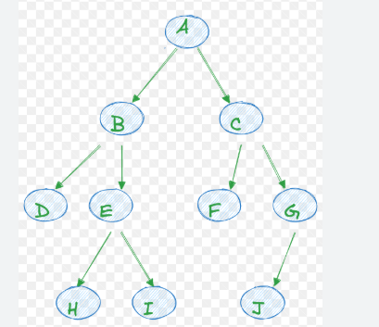
9. Define the following terms: i) State ii) Initial State iii) State Space. Consider the Water jug problem: A Water Jug Problem: You are given two jugs, a 4-gallon one and a 3-gallon one, a pump which has unlimited water which you can use to fill the jug, and the ground on which water may be poured. Neither jug has any measuring markings on it. How can you get exactly 2 gallons of water in the 4-gallon jug? Give the state space representation for the Water Jug Problem. (5M)
10. Apply Best First Search and Find the best path from Node S to Node G with using the given Heuristic Function. (5M)
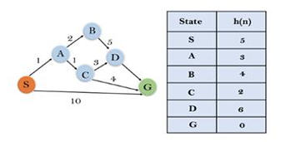
UNIT-2: Short Answer Questions
1. Define Adversarial Search.
2. Differentiate between game playing problems and state space problems.
3.How does Alpha-Beta pruning improve the efficiency of Minimax?
4.Define a Constraint Satisfaction Problem (CSP).
5. Differentiate between Backtracking Search and Local Search for CSPs.
6.Define Propositional Logic and list its main logical connectives.
7.What is a Knowledge-Based Agent?
8. Define Constraint Propagation.
9.Differentiate between a Definite Clause and a Horn Clause.
10.Define Model Checking in Propositional Logic.
UNIT-2: Essay Questions
1. Perform Alpha-Beta Pruning in the two-player game tree given below.
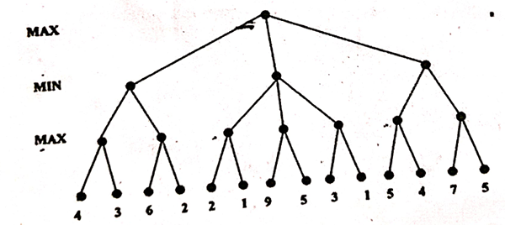
2. Apply constraint satisfaction procedure for solving the crypto arithmetic problem. 
3.Find the root node value for given graph using Min-Max approach.
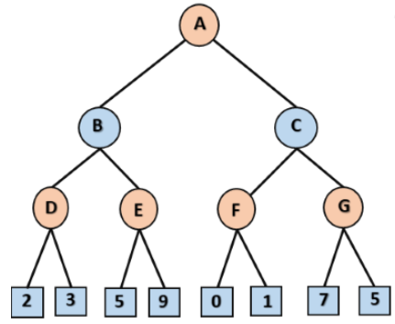
4.How the propositional logic is useful in Knowledge based agent? Explain with an example.
5. Explain and Differentiate between Forward and Backward Reasoning with examples.
6. Design a knowledge base for the Wumpus World and show inference.
7. Consider the following knowledge base:
1. The-humidity-is-high v the-sky-is-cloudy.
2. If the-sky-is-cloudy then it-will-rain
3. If the-humidity-is-high then it-is-hot.
4. it-is-not-hot
and prove that : it-will-rain by using propositional logic Resolution method.
8. Explain Constraint Propagation techniques, including Node Consistency, Arc Consistency (AC-3), and Path Consistency.
9. Prove or disprove $C∨\left(¬A∧¬B\right)≡\left(A⇒C\right)∧\left(B⇒C\right)$)
10. Explain about Syntax and Semantics in propositional Logic with examples.
UNIT-3 Short Answer Questions
1.What is First-Order Logic (FOL) and how does it differ from Propositional Logic?
2.Define Knowledge Engineering in FOL.
3.Explain the function of Quantifiers in FOL.
4.What is Universal Instantiation and Existential Instantiation?
5.Define Unification in First-Order Logic.
Long Answer Questions
1.Explain the syntax and semantics of First-Order Logic (FOL) with detailed examples involving terms, predicates, and quantifiers.
2.Explain the process of Knowledge Engineering in FOL through a step-by-step domain modelling example.
3.Explain the Unification Algorithm in detail with suitable examples showing matching of expressions.
4.Convert the following statements into predicate logic
1. Marcus was a man.
2. Marcus was a Pompeian.
3. All Pompeian’s were Romans.
4. Caesar was a ruler.
5. All Pompeian’s were either loyal to Caesar or hated him.
6. Everyone is loyal to someone.
7. People only try to assassinate rulers they are not loyal to.
8. Marcus tried to assassinate Caesar.
Translate above statements into First Order Logic (FOL).
5. Explain about Inference rules in First Order Logic with examples.

